Safety Planning for Young People
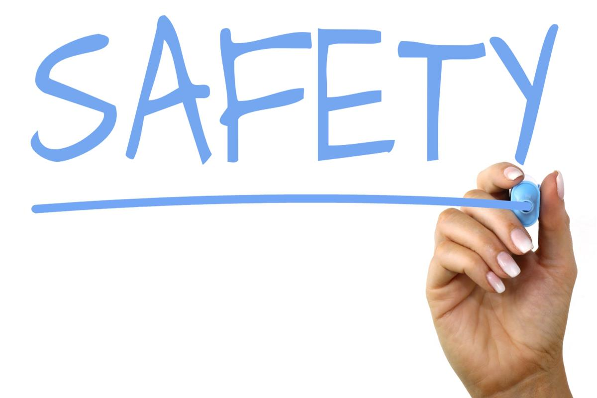
- Carry mobile phone at all times; always ensure it is fully charged with credit/minutes available.
- Identify an adult you can trust and who you can talk to.
- Report incidents of abuse to someone you trust.
- Keep a log of any forms of abuse, harassments or threats.
- Avoid walking in any remote places alone, e.g. alleyways.
- Consider blocking the abuser from social media and from your phone, however, if you prefer to gather evidence of messages received to log with the police, think about how you feel about this and the impact it may have on you if you don’t block them.
- Ensure your location services are turned off on Facebook so your whereabouts can not be tracked.
- Consider changing elements of your daily routine that the abuser may be aware of.
- Where possible, always make sure you do not go out alone/ try not to walk from school or work alone.
- Contact 999 if you feel in any immediate danger.
- Contact 101 to log any incidents of abuse, harassment or threatening behaviour.
- Inform a family member/friend where you are going and what time you plan to be back.
- Keep a passcode on your mobile phone.
- Never give your personal passwords out to anyone other than your parents/carers
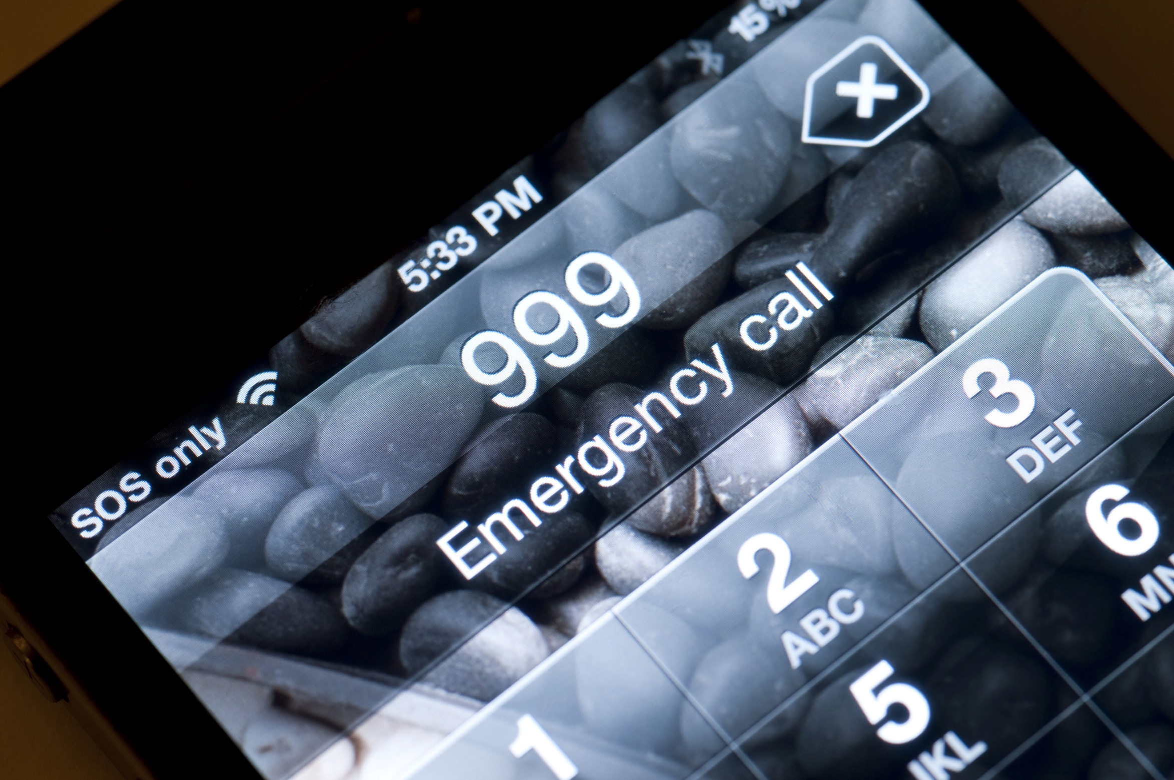
Staying safe at home
Family members you can speak to/confide in about your current situation:

Where can you go at home that is the safe?

Are there any times you are home alone? If so when?

The safest way I can leave my house in an emergency (think about the house layout and find the easier route out):

If I did need to leave in an emergency, where could I go?
A code word I could use to alert my family/friends/professionals I am in danger:

