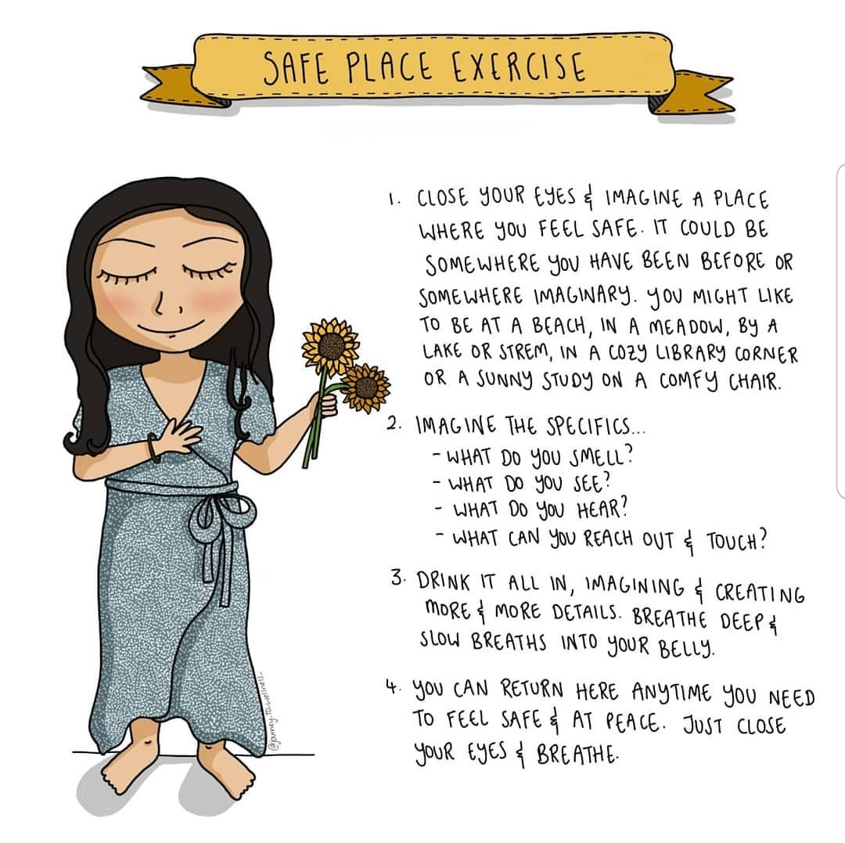

Now let’s create your own…
Were you with anyone, or were you alone?
What could you hear?
What could you smell?

What could you see?
Could you taste anything?

/
Would you like to draw your imaginary safe space?

