National Stalking Awareness Week 2024 22-26 April

Suggested date/time | Post | Image
Monday 22 am | It’s National Stalking Awareness Week 22-26 April 2024  Stalking can happen to anyone.  National stalking helpline: 0808 802 0300 If you, or someone you know is in the terrifying position of being stalked, please know that this is an option for help, information and support. https://www.suzylamplugh.org/Pages/Category/national-stalking-helpline  Suzy Lamplugh Trust is a specialist stalking service that provides; trauma-informed support, advice and advocacy to victims of stalking, support campaigns, training and research into personal safety, lone working and stalking.  #NSAW2024 | 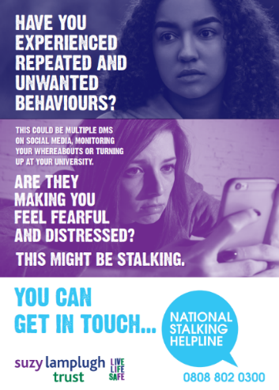
Monday 22 pm | You have the right to feel safe and be safe. If there is an area where you don’t feel safe, for whatever reason, you can let the Police know through the #StreetSafe tool. More: https://buff.ly/3UissPT  #NSAW2024 | 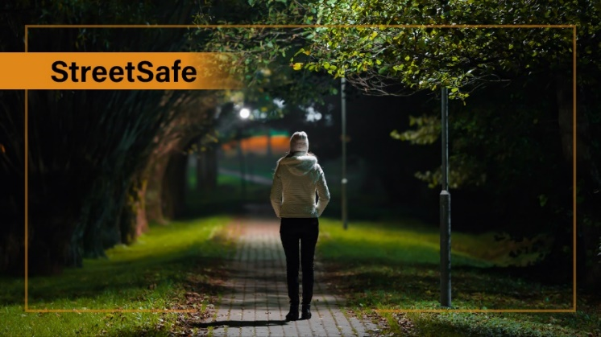
Tuesday 23 am | Do you know the FOUR indicators of stalking behaviour: Fixated, Obsessive, Unwanted, Repeated. In 2022/23 Lincolnshire police have dealt with 7644 reports of stalking and harassment. See the Lincs Police advice section for help and support: https://buff.ly/4aZBBmd  #NSAW2024 | 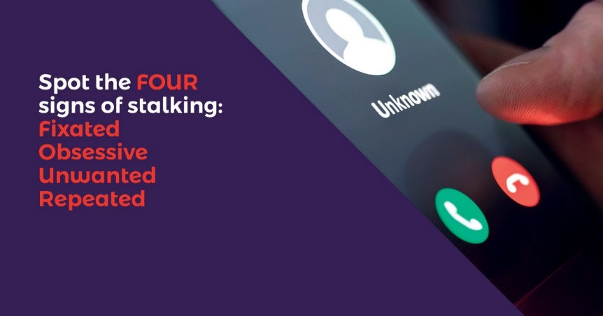  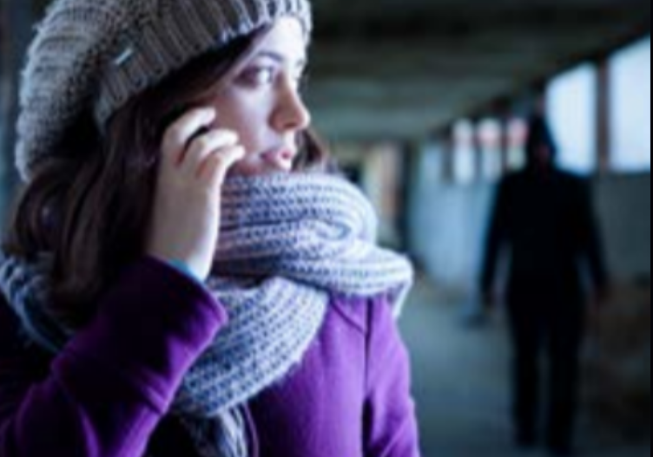
Tuesday 23 pm | Hollie Guard is an app for your phone for extra protection when travelling alone. In danger? A simple shake activates Hollie Guard, automatically sending your location & audio/video evidence to your contacts. Learn more here: http://ow.ly/t9UJ50ErSXR  #NSAW2024 | 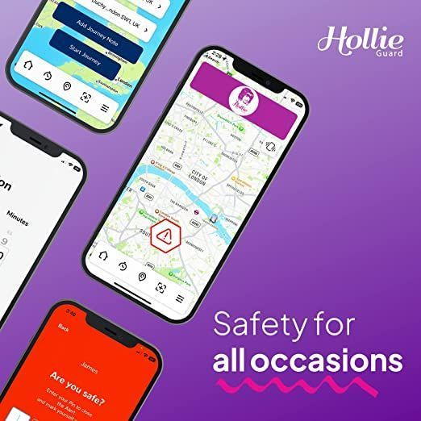
Wednesday 24 am | - Using technology to keep tabs on what someone is doing and where they are going?  - Forcing somebody to share their passwords?  - Bombarding someone with unwanted calls and messages?  It’s not normal or a cute thing couples do – it is controlling. This could be a sign of stalking behaviour. Stalking is fixated, obsessive behaviour which is unwanted and repeated. Does this sound like you?  According to Cyber Helpline, 85% of cyberstalking and online harassment victims have reported feeling less physically safe, and reported feeling their lives were shattered and careers jeopardised.  Always call 999 in an emergency. If you have been a victim of online harassment or stalking, support is available from Victim Lincs https://buff.ly/3Q2Elae  #NSAW2024 | 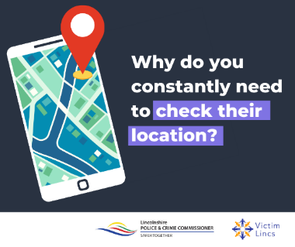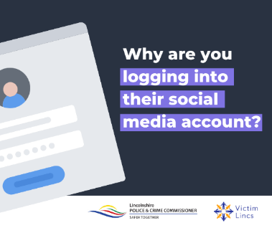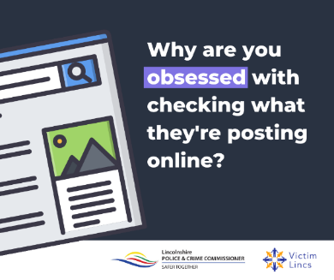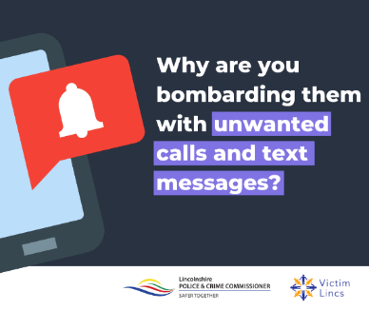
Wednesday 24 pm | If you are in an abusive relationship, stalking can be an element of that. Find out more about domestic abuse and the signs by visiting the Lincolnshire Domestic Abuse Specialist Service website: https://ldass.org.uk/ or contact LDASS Support Hub 01522 510041 Opt 2 Mon-Fri 9-5  #NSAW2024 | 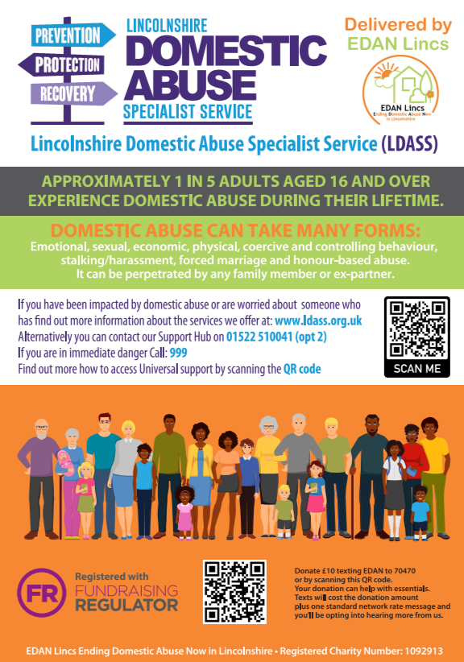
Thursday 25 am | Alice Ruggles Trust is a specialist stalking service that helps raise awareness of stalking and the risks associated with it, supporting training and research and campaigning for provisions for victims. They produced a video to raise awareness of stalking https://buff.ly/3U02j7d  For more info visit https://buff.ly/4aTtveB  #NSAW2024 | If you need to display an image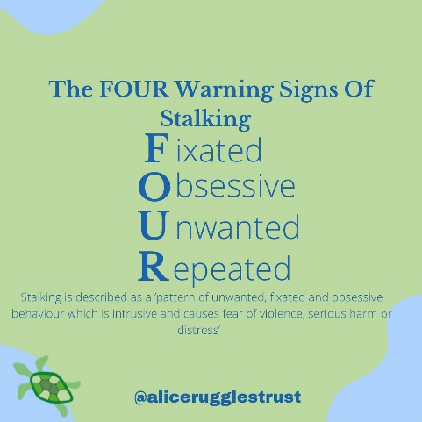
Thursday 25 pm | Stalking is a form of domestic abuse, often considered as emotional abuse. Stalking can include the perpetrator following, harassing, or monitoring. If you are worried that you are being stalked by a current or ex partner, SOLDAS can offer free and confidential advice at their Rural Community Hubs. SOLDAS is South of Lincolnshire Domestic Abuse Service. To book an appointment email admin@bostonwa.co.uk or call SOLDAS helpline on 01205 311272. #NSAW2024 | 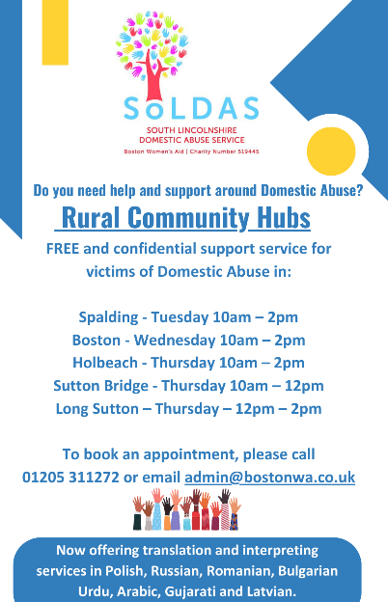
Friday 26 am | Paladin National Stalking Advocacy Service is a specialist stalking service that provides; trauma-informed support, advice and advocacy to high-risk victims, raise awareness of the dangers and risks associated with stalking  Facebook: Paladin National Stalking Advocacy Service  Instagram: Paladin_NSAS  Twitter: @paladinservice  Support and Contact details  Paladin National Stalking Advocacy Service  Website: https://www.paladinservice.co.uk/  Telephone: 020 3866 4107  #NSAW2024 | 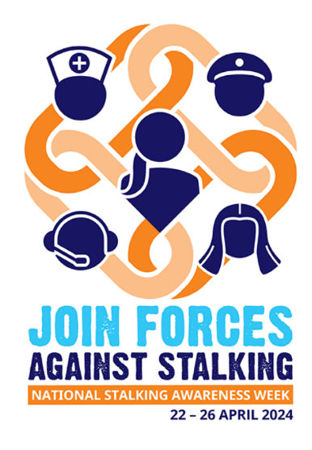
Friday 26 pm | Stalking is unwanted behaviour carried out by obsessive or fixated individuals whose actions disrupt their victim’s life. It results in alarm, distress or fear of violence in a victim. It may also escalate to other crimes. Visit CrimeStoppers for more information https://buff.ly/3w3P25z  #NSAW2024 | 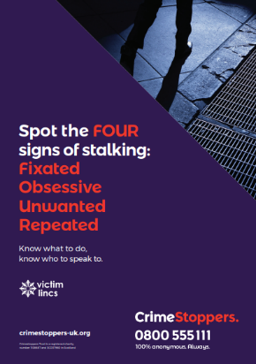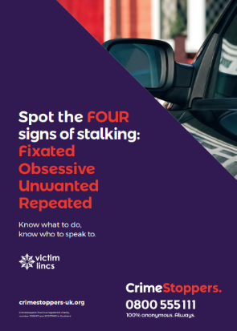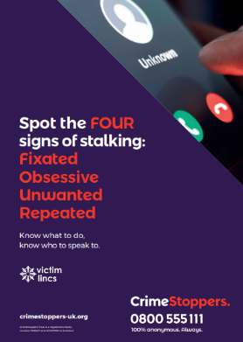

National Stalking Awareness Week 2024 22-26 April
Twitter version

Suggested date/time | Post | Image
Monday 22 am | It’s National Stalking Awareness Week 22-26 April 2024 Stalking can happen to anyone. National stalking helpline: 0808 802 0300 https://buff.ly/2G1Eyag #NSAW2024 | 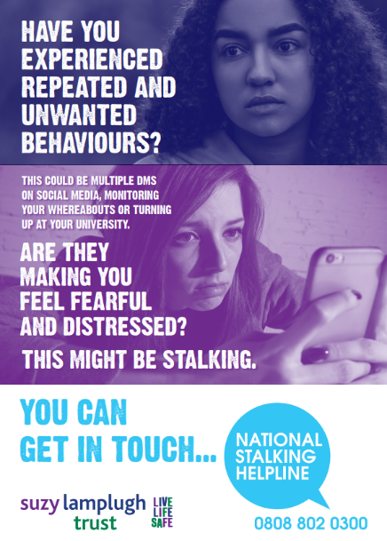
Monday 22 pm | You have the right to feel safe and be safe. If there is an area where you don’t feel safe, for whatever reason, you can let the Police know through the #StreetSafe tool. https://buff.ly/3UissPT  #NSAW2024 | 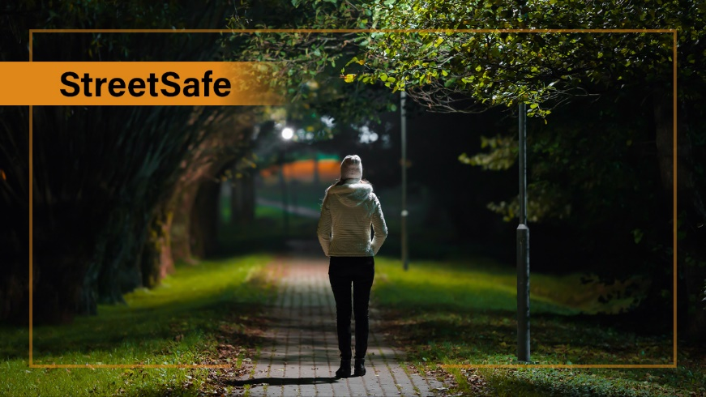
Tuesday 23 am | Do you know the FOUR indicators of stalking behaviour: Fixated, Obsessive, Unwanted, Repeated.  In 2022/23 Lincolnshire police have dealt with 7644 reports of stalking and harassment.  See the Lincs Police advice section for help and support: https://buff.ly/4aZBBmd  #NSAW2024 | 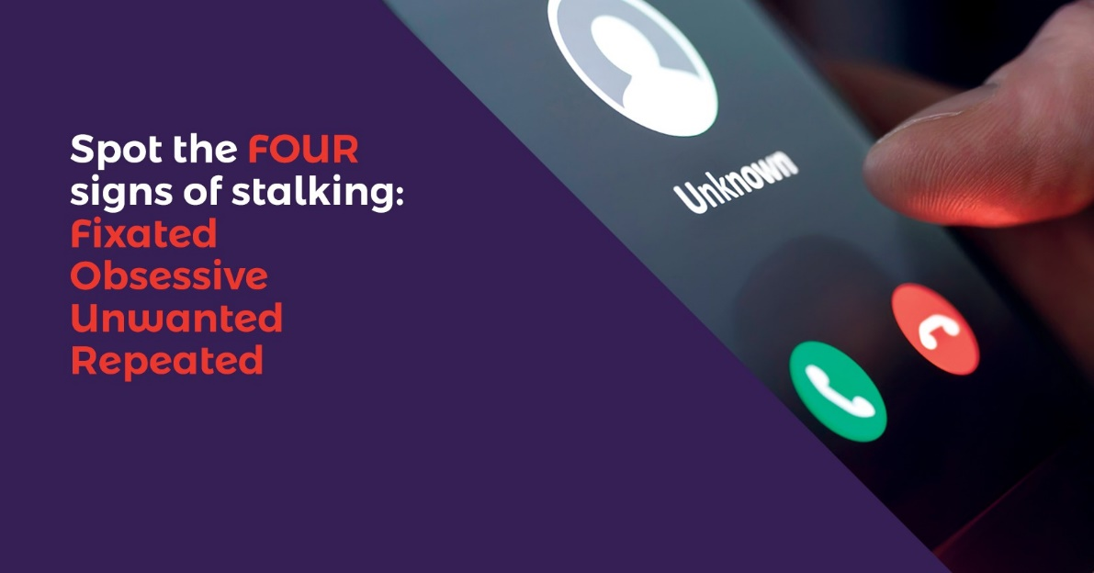
Tuesday 23 pm | Hollie Guard is an app for your phone for extra protection when travelling alone. In danger? A simple shake activates Hollie Guard, automatically sending your location & audio/video evidence to your contacts. Learn more here: https://buff.ly/3W1fszA  #NSAW2024
Wednesday 24 am | Using technology or social media to keep tabs on what they are doing & where? Bombarding someone with unwanted calls & messages?  This could be a sign of stalking behaviour.  Always call 999 in an emergency.  Contact Victim Lincs https://buff.ly/3Q2Elae  #NSAW2024
Wednesday 24 pm | If you are in an abusive relationship, stalking can be an element of that. Find out more about domestic abuse and the signs by visiting the Lincolnshire Domestic Abuse Specialist Service https://ldass.org.uk/ or contact LDASS Support Hub 01522 510041 Opt 2 Mon-Fri 9-5  #NSAW2024
Thursday 25 am | Alice Ruggles Trust is a specialist stalking service that helps raise awareness of stalking & the risks associated with it. They produced a video to raise awareness of stalking https://buff.ly/3U02j7d  https://buff.ly/4aTtveB  #NSAW2024 | If you need to display an image
Thursday 25 pm | If you are worried that you are being stalked by a current or ex partner, SOLDAS can offer free & confidential advice at their Rural Community Hubs. SOLDAS is South of Lincolnshire Domestic Abuse Service. Book appointment admin@bostonwa.co.uk or call SOLDAS 01205 311272 #NSAW2024
Friday 26 am | Paladin National Stalking Advocacy Service is a specialist stalking service that provides; trauma-informed support, advice and advocacy to high-risk victims, raise awareness of the dangers and risks associated with stalking  Visit https://buff.ly/4231htl  020 3866 4107  #NSAW2024
Friday 26 pm | Stalking is unwanted behaviour carried out by obsessive or fixated individuals whose actions disrupt their victim’s life. It results in alarm, distress or fear of violence in a victim. It may also escalate to other crimes. More here https://crimestoppers-uk.org/keeping-safe/personal-safety/stalking  #NSAW2024 | 