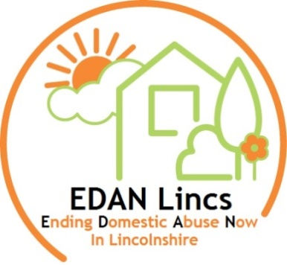
Experiencing Domestic Abuse?
We are here to help!
Formally known as West Lincolnshire Domestic Abuse Service
We are a County wide domestic abuse service that operates in all districts in Lincolnshire providing support to individuals and families affected by domestic abuse.
Specialist support around domestic abuse can vary but includes:
- Safety planning  - 1:1 practical / emotional support and crisis intervention  - Family support and direct support for children. | - Support in accessing legal advice and other services  - Support in Court  - Courses / group support designed for survivors.
Helpdesk:
EDAN Lincs offers a county wide helpdesk service that operates:
Monday to Friday, 9am – 5pm.
It is managed by specialist staff that are able to offer immediate support and advice and take referrals for EDAN Lincs support.
Contact:01522 510041^{or}email:info@edanlincs.org.uk
Drop-ins:
If you want to speak to one of our specialist workers face-to-face, you can come to one of our domestic abuse drop-in surgeries, these are held at:
Skegness  Every 1st and 3rd Friday of the month: 1.00pm – 3.00pm  Skegness Children's Centre, Brunswick Drive, Skegness,  PE25 2QT | Lincoln  Every 2nd Tuesday of the month 1.00pm-3.00pm at St Swithins Community Centre, Croft Street  Lincoln, LN2 5AZ  &  Every 4th Thursday of the month: 1.00pm – 3.00pm at Life Church 127-129 Birchwood Ave,  Lincoln LN6 0JE | Spalding  Every 2nd and 4th Friday of the month: 10.00am-12.00pm  Citizens Advice Bureau  Council Offices, Priory Rd, Spalding PE11 2XE
Grantham  Every 1st Thursday of the month  9.30am - 12.00pm  Eden House Hotel  130 North Parade, Grantham NG31 8AU | Louth  Every 2nd Monday of the month: 9.30am- 12.00pm  Louth Children’s Centre  Lacey Gardens  Louth LN11 8DQ | Boston  Every 1st Monday of the month: 9.30am -12.00pm  Ringrose Law , Endeavour House, 3 Gilbert Dr, Boston  PE21 7TR

I

Prior to attending one of our drop-ins, please visit our website www.edanlincs.org.uk to check there have been no amendments to dates/times.

