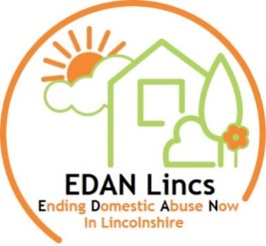
EDAN Lincs Domestic Abuse Service
Application for Employment

Title: Deputy to CEO
Reference:

This form can be completed in either your own writing or electronically. CV’s will not be accepted. Please read all the instructions carefully before completing this form and return the completed form to: EDAN Lincs Domestic Abuse Service, PO Box 125, Lincoln, LN1 1HA

We appreciate that previous service users may wish to apply for a position either paid or voluntary within the organisation as they can bring valuable experience. Please be aware that we recommend all applicants are at least 12 months ‘out of service’ before applying for any roles.

Do you give consent for EDAN Lincs to check your name against internal records? Yes ☐ No ☐

Personal Details:
Surname: | Preferred title (if any):
Forename(s):
Home address:  Postcode: | Correspondence address:  (if different from home address):  Postcode:
Telephone number(s) (list only those you may be contacted on during business hours):
Email address (note as above):
Yes No ()  Car driver: ☐ ☐  Full driving licence: ☐ ☐ | Yes No  Full use of car: ☐ ☐  Do you need a work permit? ☐ ☐
In the last 12 months, how many days absence have you had for sickness?
Rehabilitation of Offenders Act 1974 – notice to applicants
Because of the nature of the work, where post holders will have access to young persons, they are exempt from the provisions of Section 4(2) of the Rehabilitation of Offenders Act 1974. Applicants for this post are therefore not entitled to withhold information about convictions which for other purposes are “spent” under the provisions of the Act. In the event of employment, any failure to disclose such convictions will result in disciplinary action or dismissal. This information will be treated as confidential and will be considered only in relation to posts to which the order applies.
Yes No
Do you have any criminal convictions to disclose? ☐ ☐
and if “yes”, please give details:

Previous Employment: Start with current/most recent employer and include voluntary work. Use an additional sheet if required.

Employer’s name and nature of business | Position held and brief description of duties | From – To  Month/Year | Reason for leaving

Education and Training:
School/College  University/etc | Course Title and any Qualification Gained | From – To  Month/Year

Personal Statement: Please give a concise account of how your experience, skills and knowledge are relevant to this post and the work involved. Make sure you have first read the job description and person specification carefully and use this section to demonstrate how you meet the criteria, giving examples where possible. Please include any voluntary work, any involvement with women’s, community or voluntary organisations, including any involvement whether as a volunteer or a service user of domestic abuse services and all other like experience. Please include your present and previous employment. Please use an additional sheet if required.

References:

Please give the names and addresses of two business or professional referees (NOT relatives, partners or personal friends). These should include your present or, if currently unemployed, your most recent employer. Students should give the name of their Course Tutor or Head Teacher, as appropriate.

If a referee knows you by a name other than the surname shown overleaf, please state that name here, indicating referee 1 or 2:

If you do not wish your present employer to be contacted at this stage, please write “No” in the box:

1. Name: | 2. Name:
Position/Title: | Position/Title:
Address:  Postcode: | Address:  Postcode:
Telephone: | Telephone:
Email: | Email:
Capacity in which referee knows you: | Capacity in which referee knows you:

EDAN Lincs is committed to safeguarding and promoting the welfare of people experiencing domestic abuse, children, young people and vulnerable adults. All staff have an absolute responsibility to safeguard and promote the welfare of children and adults. Please note that information provided to you by us will be checked. We will undertake DBS checks, identity check and will check references and qualifications which will be verified by us. Such checks will include checks of previous voluntary work, including any voluntary work, any involvement with women’s, community or voluntary organisations, including any involvement whether as a volunteer or a service user of domestic abuse services. Please include your present and previous employment.

All personal data held about you will be held in accordance with EDAN Lincs’ Data Protection Policy, a copy of which is available at www.edanlincs.org.uk.

Declaration

I hereby declare that the information given in my application is correct to the best of my knowledge.

Signature: Date:

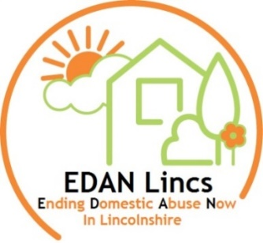
EDAN Lincs Domestic Abuse Service
Monitoring Form

EDAN Lincs Domestic Abuse Service is aiming to achieve equal opportunities in employment. To help us monitor the effectiveness of our equal opportunities policy, you are asked to complete the following questions. If you do not wish to answer any of the questions, you may leave them blank.
Completion of this form is voluntary and will not affect your application in any way as it will not be seen by the selection panel.

Please one box

1. How would you describe your ethnic origin?
Black African: Black Caribbean: Black Other:
Indian: Bangladeshi: Pakistani:
White British: White European: Other:
3. Do you consider you have a disability?
yes: no:
4. How would you describe your sexuality?
Heterosexual: GLBT:
5. Do you have dependants, or are you a carer?
yes: no:
6. Where did you see this post advertised? (please specify):

Thank you for taking the time to complete this form.

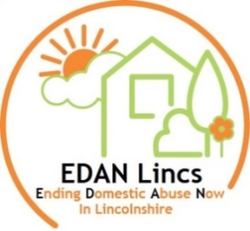
Organisation
Board of Trustees
Chair of Trustees, Vice Chair, Treasurer and
Company Secretary – Total of 9 Trustees
Structure 2021
EDAN Lincs Manager (Chief Executive Officer)
Referral to
Floating Support

Refuge (Lincoln)
Project Manager
Outreach
Project Manager
Outreach
Project Manager
Outreach
Project Manager
IDVA
Project Manager

Outreach
Project Manager
Refuge (Louth)
Project Manager

MARAC
Manager

IDVA
7 x Independent Domestic Violence Advisers
2 x Hospital IDVAs
1 x Court IDVA
1 x Rural IDVA
1 x CYP IDVA

Outreach
1 x Senior Domestic Abuse Worker

Targeted Children’s Service
1 x Senior Child Young Person (CYP) Worker

Refuge
2 x Lead Refuge Worker (Lincoln & Louth)

1 x Lead Family/Child Support worker (BBC CIN) (Lincoln)

Refuge Services
4 x Specialist
DA Workers (Lincoln)
2 x Specialist
DA Workers (Louth)
Family/Child Support (BBC CIN)
1 x Dispersed Refuge Specialist DA CYP Worker (Lincoln)
1 x Family Play Worker (Lincoln) 1 x Sessional Worker (Lincoln)
I x Children’s CYP (Louth) (BBC CIN - negotiation re transfer of funding)

Outreach DA Services

2 x Information, Advice and support Worker
4 x Domestic Abuse Triage Assessment Workers

A team of Specialist Domestic Abuse ‘Short Term’ Intervention (telephone hub) workers
A team of Specialist Domestic Abuse ‘Intensive Intervention’ workers

Targeted Children’s Services

A Team of Child/Young Person Specialist Domestic Abuse Workers
EDAN SAFE Course
EDAN SAFE Programme (Includes impact on Children/young people)

Finance Director

Finance Controller

1 x HR Project Administrator/PA

1 x Project Admin (Refuge)

1 x Fundraising Co-ordinator
Volunteers
Funded by:

