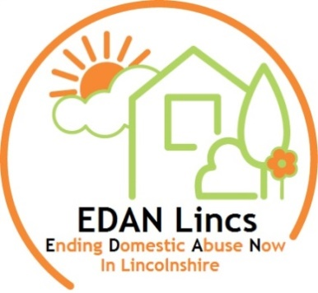
EDAN Lincs Domestic Abuse Service

Information, Advice & Support (IAS) Worker
Up until 30/11/22 – subject to funding thereafter
20 hours per week
£19,000 FTE

Are you committed and enthusiastic to making a difference to those affected by domestic abuse?
Do you feel passionate about ‘Ending Domestic Abuse Now’ in Lincolnshire?

The role will primarily entail being the first ‘port of call’ into the service; answering the phone and providing information, advice and support to those who call. The role can be varied, dynamic and fast-paced, and require a good level of communication and able to build rapport quickly. Relevant experience or knowledge around domestic abuse is desirable. NVQ level 3 or equivalent experience if required.

EDAN Lincs is a Lincolnshire countywide Domestic Abuse Service offering refuge, outreach and IDVA support. EDAN Lincs upholds safeguarding requirements and our agency is committed to safeguarding vulnerable adults and children. Any offer of employment is subject to satisfactory pre-employment checks, which include: Identity verification; Qualification verification; DBS clearance; References.

For an application pack, contact:
EDAN Lincs Domestic Abuse Service, PO Box 125, Lincoln, LN1 1HA
Email: info@edanlincs.org.uk
Telephone: 01522 510041 (option 2)
Closing Date: 12pm on Monday 23rd August, 2021

