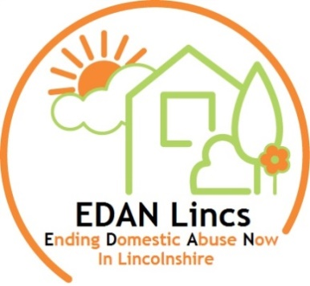
EDAN Lincs Domestic Abuse Service

EDAN Lincs Domestic Abuse Service provides refuge accommodation, floating support and a wide range of support services for all who suffer domestic abuse; thus promoting safety, well-being and independence within the community. Our main office is based in Lincoln however we provide support to the whole of Lincolnshire.
EDAN Lincs upholds safeguarding requirements and our agency is committed to safeguarding vulnerable adults and children. Any offer of employment is subject to satisfactory pre-employment checks, which include: Identity verification; Qualification verification; DBS clearance; References.

Specialist Domestic Abuse Worker (Bank Staff)
6 month contract starting 17th August, 2020 – subject to funding thereafter, hours may vary thereafter
Bank Hours (as and when needed)
£19,000 FTE

We are looking to recruit committed and enthusiastic individuals to join our dedicated team to provide support for individuals/families who have been affected by living with abuse. The post holder will be required to provide direct support and intervention to adults, children and young people affected by domestic abuse.
Relevant experience or knowledge of the causes and effects of domestic abuse on adults, children and young people is essential.
NVQ level 3 or equivalent experience is required.
(A car driver & access to a vehicle for work purposes is essential for these post)
For an application pack, contact:
EDAN Lincs Domestic Abuse Service,
PO Box 125. Lincoln, LN1 1HA
Email: info@edanlincs.org.uk
Telephone: 01522 510041
Closing Date: 12pm on Friday 24th July, 2020

Interviews date: 29th and 30th July, 2020

