PO Box 125 Lincoln LN1 1HA
Telephone: 01522 510041
Email: info@edanlincs.org.uk

30 July 2026

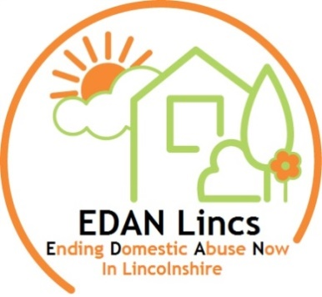

Post of Specialist Domestic Abuse Worker (Bank Hours)
Thank you for your application request for the above post.
When completing the application form contained within the enclosed recruitment pack please ensure that you demonstrate how you meet the person specification.
Please do not include a CV as it will not be considered.
As with all charity based work, all posts are subject to funding.
The closing date for the post is 12 noon on Monday 24th July, 2020.
It is not possible to contact everyone who makes an application. If you have not heard from us by close of day on Monday 27th July 2020, you will have been unsuccessful on this occasion. Please note interviews will be held on 29th and 30th July.
Please send your completed application form (marked “private and confidential”) to:

Celia Madden, (CEO)
EDAN Lincs Domestic Abuse Service
PO Box 125
Lincoln
LN1 1HA

Alternatively: you can e-mail your application to: info@edanlincs.org.uk

Yours faithfully

Celia Madden (CEO)
EDAN Lincs Domestic Abuse Service
Tel: 01522 510041 (option 2)

